VERIFICATION OF WSL INSTALLATION:
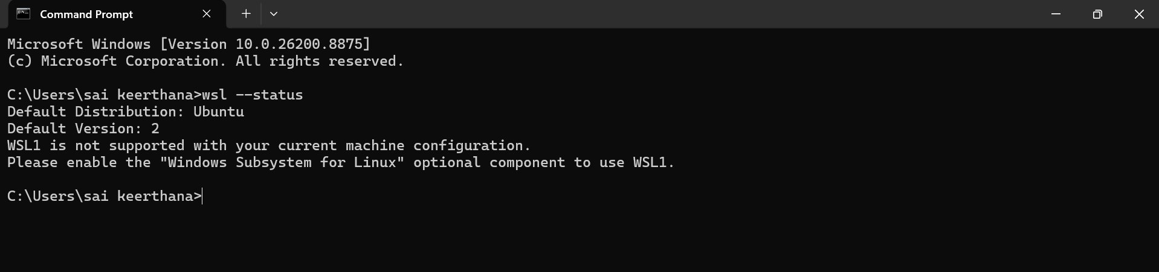
VERIFICATION OF GCC VERSION:
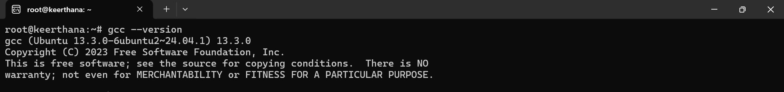
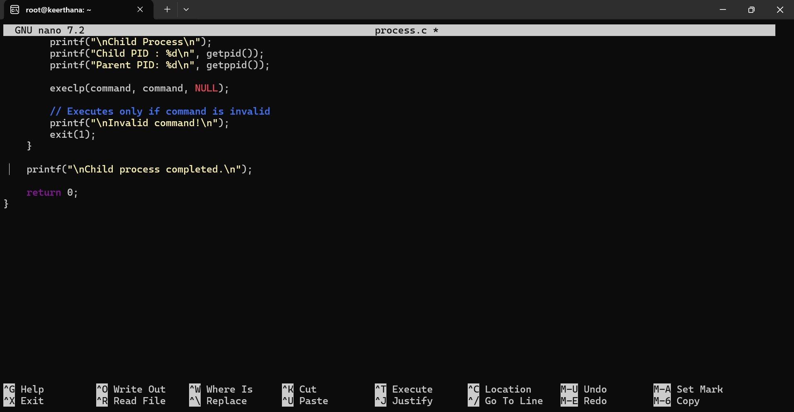
GCC PROGRAM:

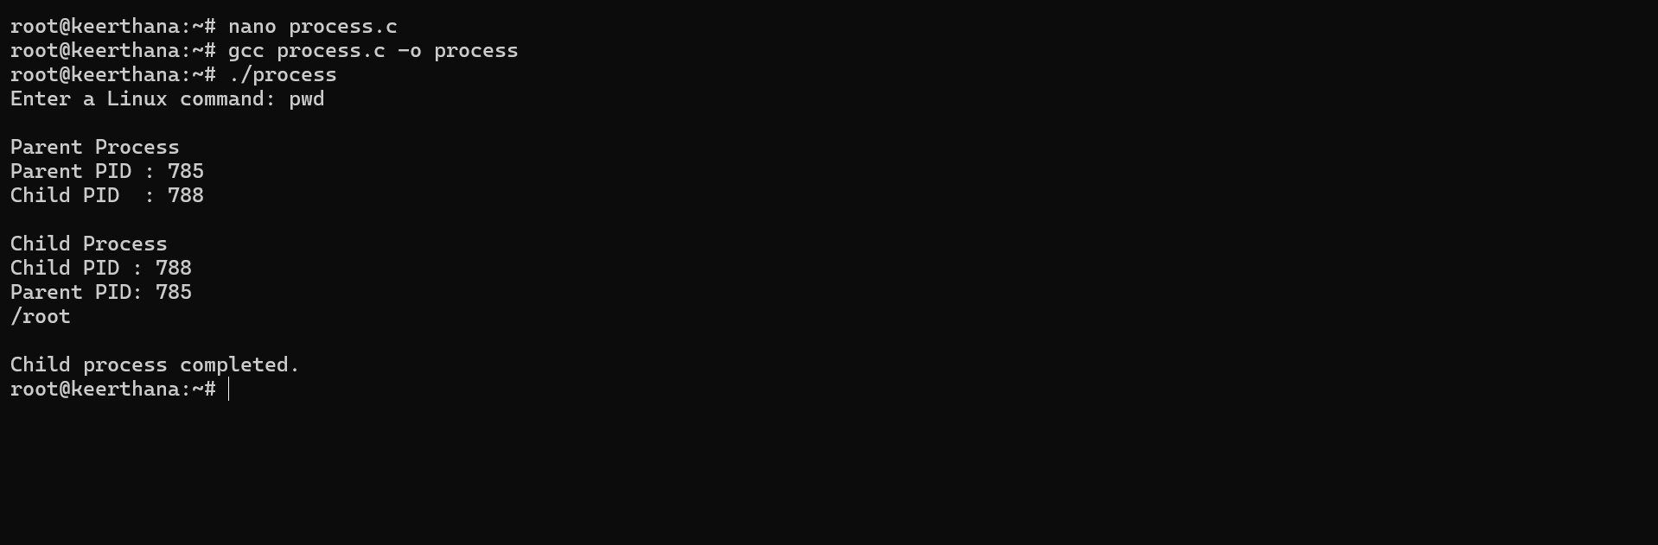
SIMPLE COMMANDS:
